Technical Report

**Capstone Project:**

**A Point-of-Sale Web Application using PHP Language**

Abdelrahman Abu-Zahra

January 2023

**1. Executive Summary**

A store owner is facing management problems that resulted in reducing the productivity and unauthorized actions. the owner wants a computerized based on the roles of the employees, the four role is: Admin, Seller, Accountant and procurement. Every role has a permissions to access certain dashboard. The seller access only Selling dashboard, the accountant access only the transaction dashboard, and procurement can access only the inventory dashboard. The admin can access everything and create, edit or delete any user.

**2. Introduction**

The owner of the store pointed out that manual systems are time-consuming, slow process, not user-friendly and difficult to find records. The other stores use various systems with technologies and have an automated Point-of-Sale (POS) system, POS system allows the business owner to manage the inventory, sales transactions and procurements process, and take care of the problems.

This report is concerned with converting the manual operations in the store into a computerized system to ease out problems. Thus, by enhancing the process to be more efficient, fast and accurate, the store certainly increases its productivity and competes with the other stores.

**3. Object**

The project consists of six objects to handle the store operations based on the users roles (administrator, seller, accountant and procurement).

1. informative dashboard the consist the following information: total sales, total transaction, total quantity, total users and top five expensive items to buy. The administrator only accesses the informative dashboard.
2. Seller Dashboard: the seller dashboard consists of a selling form with item name and item quantity. In the same page the seller should be able see all the transactions that have been today and can edit or delete each transaction. Also, the seller cannot sell items that are out of stock. The seller can do the CRUD operations on a single page without reloading or moving to another page using AJAX requests developed by jQuery library. The administrator and sellers only access the seller dashboard.
3. inventory dashboard: the inventory dashboard lists all the items and provides all CRUD functionality for each item, each item should have id, cost price, selling price, quantity, created at and updated at fields. The administrator and procurements only access the inventory dashboard.
4. transactions dashboard: the transactions dashboard lists all the transactions and provides only read, update and delete functionality for each transaction. Each transaction should have item id, quantity, total sale, created at and updated at fields. The transaction dashboard is only accessed by the administrator and the accountants.
5. c) Users Dashboard: The Users dashboard lists the users and provides the CRUD fictionality for each user. Each user should have a display name, username, password, email, role, created at and updated at. Each user should be able to view or update his/her information. Users the administrator only accesses dashboard.
6. Login page must be the home page for the web application, this page will direct the user to the accessible dashboard.

**4. Methodology**

The system utilizes PHP as server-side language, and HTML, CSS and JavaScript as front-side languages.

BOOTSTRAP 5 have been used to make the website responsive and mobile-friendly.

AJAX requests “GET, POST, PUT and DELETE” has been implemented to allow the seller to make all CRUD functionality without reloading or moving to another the page, and it has been developed using jQuery library.

The web application has been built using Model, View and Controller (MVC) design pattern, which is commonly used for better division of labor, improving the maintenance and organizing the script. The three parts of MVC design pattern can be described as follows:

1) Model: manage the data and business logic.

2) View: handles the layout and displays it to the user.

3) Controller: routes the commands to the model and view parts.

MYSQL is used as a relational database management system.

**5. Result**

1. The main page for the website is responsive and contain “remember me” functionality.

Figure 1: Login Page

1. Informative Dashboard: the informative dashboard serves as the main page for the store owner or the administrator. And it consists of all the required objects as shown in “Figure 2”.

Figure 2: Admin Informative Dashboard

1. Sales Page: the sales dashboard serves as the main dashboard for the seller role. The seller can create, edit or delete a transaction in the same page without reloading or moving to another page, using AJAX requests. The dashboard will view only transactions that has been made today by the current logged in user.

Figure 3: Sales Dashboard

1. Transaction Dashboard: The dashboard serves as the main page for the accountant role. The accountant can only view, edit or delete a transaction through pages.

Figure 4: Transactions Page

Figure 5: View single transaction.

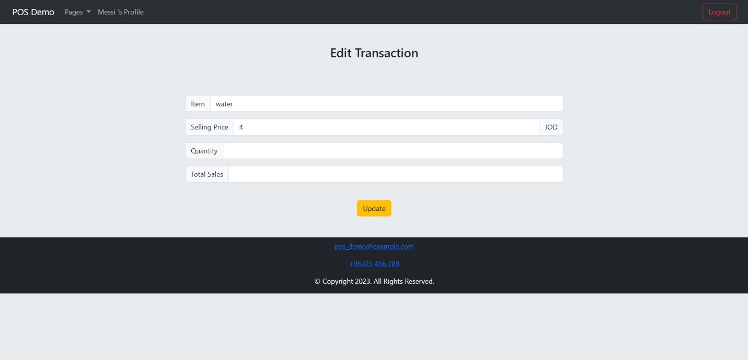

Figure 6: Edit single transaction.

1. Inventory Dashboard: The dashboard serves as the main page for the procurement role. The procurement can create, view, update and delete the item information through pages as shown in the following figures.

Figure 7: Inventory dashboard

Figure 8: create an item.

Figure 9: View single item.

Figure 10: Edit single item.

1. The Users dashboard: The dashboard is only accessed by the administrator. The admin can view, create, edit and delete the user information. The admin also can edit role of the user. The admin can view the transaction that has been made by the selected user in his page.

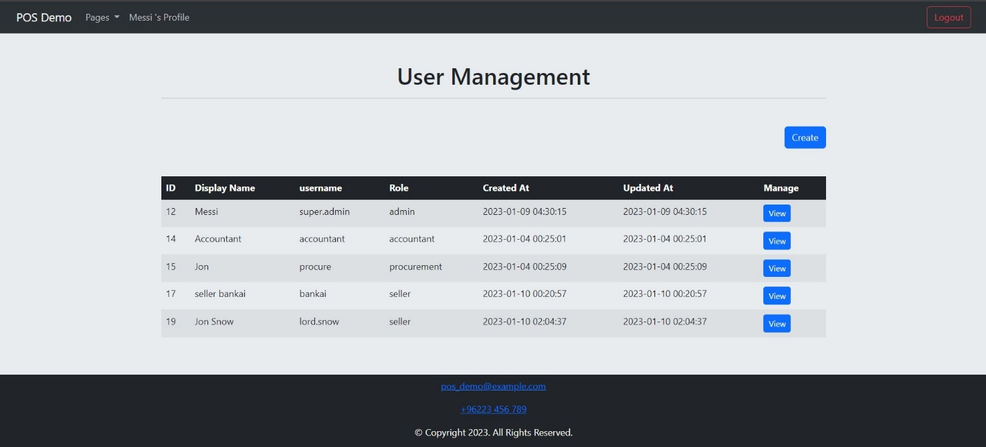

Figure 11: Users Dashboard

Figure 12: Create an user.

Figure 13: Edit user information.

Figure 14: View single user.

1. Profile Page: Each user can view and edit his/her display name, username and email.

Figure 15: Profile Page

Figure 16: Edit Profile Page.

**6. Discussions:**

The owner of the store was facing management problems using the manual system. These problems result in low productivity, time consuming and difficulties when searching for old records. The computerized system is solving all these problems. And now the store can compete with the other stores, thus increasing the store incomes.

The web application is based on roles and no user can access all the web. Every user has a specific permission to secure the store from unauthorized actions.

**7. Conclusions:**

The website is consistent with the required objectives: informative, selling, transactions, inventory and users’ dashboards. Every user has a certain permission to access only the required dashboard based on the role. The owner or the administrator has the permissions to access all the dashboards and control the users.

**8. References:**

<https://www.w3schools.com/>

<https://developer.mozilla.org/en-US/>